### **AI-powered Nutrition Analyzer for Fitness Enthusiasts**

ID: TEAMPNT2022TMID10936

VARSHA P 811519104114

LATCHIYA K.S 811519104063

PAVITHRA A 811519104083

SHINY ROSHINI J 811519104098

**Project Report**

**1. INTRODUCTION**

1.1 Project Overview

1.2 Purpose

**2. LITERATURE SURVEY**

2.1 Existing problem

2.2 References

2.3 Problem Statement Definition

**3. IDEATION & PROPOSED SOLUTION**

3.1 Empathy Map Canvas

3.2 Ideation & Brainstorming

3.3 Proposed Solution

3.4 Problem Solution fit

**4. REQUIREMENT ANALYSIS**

4.1 Functional requirement

4.2 Non-Functional requirements

**5. PROJECT DESIGN**

5.1 Data Flow Diagrams

5.2 Solution & Technical Architecture

5.3 User Stories

**6. PROJECT PLANNING & SCHEDULING**

6.1 Sprint Planning & Estimation

6.2 Sprint Delivery Schedule

6.3 Reports from JIRA

**7. CODING & SOLUTIONING (Explain the features added in the project along with code)**

7.1 Feature 1

7.2 Feature 2

7.3 Database Schema (if Applicable)

**8. TESTING**

8.1 Test Cases

8.2 User Acceptance Testing

**9. RESULTS**

9.1 Performance Metrics

**10. ADVANTAGES & DISADVANTAGES**

**11. CONCLUSION**

**12. FUTURE SCOPE**

**13. APPENDIX**

**INTRODUCTION**

**1.1 PROJECT OVERVIEW**

Food is essential for human life and has been the concern of many healthcare conventions. Nowadays new dietary assessment and nutrition analysis tools enable more opportunities to help people understand their daily eating habits, exploring nutrition patterns and maintain a healthy diet. Nutritional analysis is the process of determining the nutritional content of food. It is a vital part of analytical chemistry that provides information about the chemical composition, processing, quality control and contamination of food.

The main aim of the project is to building a model which is used for classifying the fruit depends on the different characteristics like colour, shape, texture etc. Here the user can capture the images of different fruits and then the image will be sent the trained model. The model analyses the image and detect the nutrition based on the fruits like (Sugar, Fibre, Protein, Calories, etc.).

Nutritional intake is the basis for human growth and health, and the intake of differen types of nutrients and micronutrients can affect health. Most diseases are inextricably linked to diet. Diabetes, cardiovascular diseases (hypertension, hyperlipidemia), gout, pepticulcers, and gastroenteritis are all diet-related diseases that are increasing in prevalence every year, while the age group of those suffering from these diseases is gradually decreasing. The development of the Internet has made it possible to conduct online nutrition surveys through large-scale food and nutrition databases linked to automated dietary records, and there are now a growing number of software, platforms, and applications for nutrition surveys

**1.2 PURPOSE**

Nowadays new dietary assessment and nutrition analysis tools enable more opportunities to help people understand their daily eating habits, exploring nutrition patterns and maintain a healthy diet. Nutritional analysis is the process of determining the nutritional content of food.

This technique allows the user to determine the nutritional content of food. However, the quality of the analysis largely depends on how accurate and standardized the recipes are.Standardized recipes are ones that are adapted and retrieved for use by a foodservice operation. Using the same quantity and quality of ingredients in standardized recipes yield the same results in the nutrition analysis.The purpose of nutritional assessment, on the other hand, is to define a patient’s nutritional status, to identify clinically relevant malnutrition and to monitor changes in the patient’s nutritional status. It records anthropometric, dietary and bio-chemical measurements, clinical history, findings at physical examination and other parameters. The Subjective Global Assessment and the Mini Nutritional Assessment are nutritional assessment tools. An advantage of nutritional screening tools over nutritional assessment tools is that they require less training to administer them.

**LITERATURE SURVEY**

**2.1 Existing problem**

All measurements have components of random errors and systematic bias. Dietary intake measurements are no exception. In developing an approach to the analysis of dietary data, it is essential to consider the effect of both types of error. The estimates of nutrient intake are based on data from dietary surveys, data in food composition tables, and the computation of the nutrient intake from these two data sets. Each data set has sources of random error and bias; there is also potential for bias in the computation process. Thus, the subcommittee discussed sources of bias and variability in the data on dietary intake, food composition, and computation of nutrient intake. This chapter presents the results of its analysis of the impact of random error and systematic bias on the estimates of the prevalence of inadequate intake.

**2.2 References**

1.Scrimshaw NS, Taylor CE, Gordon JE. Interactions of nutrition and infection. Geneva: WHO; 1968.

2.Kielmann AA, Taylor CE, Parker RL. The Narangwal Nutrition Study: a summary review. American Journal of Clinical Nutrition. 1978;31:2040–2052. [[PubMed](https://www.ncbi.nlm.nih.gov/pubmed/102180)]

3.Gwatkin D, Wilcox J, Wray J. Can health and nutrition interventions make a difference? Washington DC: Overseas Development Council; 1980. (Monograph 13)

4.WHO; UNICEF. The declaration of Alma Ata. International conference on primary health care jointly sponsored by WHO and UNICEF. Geneva: WHO; 1978.

5.UNICEF. The state of the world's children. New York: UNICEF; 1982–1983.

6.United Nations. World declaration and plan of action. World Summit for Children. New York: United Nations; 1990.

7.WHO; UNICEF. Integrated Management of Childhood Illness, chart booklet. Geneva: WHO; 2008.

8.Maternal and child undernutrition. Lancet. 2008;371(9608):270–273. [7 March 2013]; <http://www.thelancet.com/series/maternal-and-child-undernutrition>. [[PubMed](https://www.ncbi.nlm.nih.gov/pubmed/18207021)]

9.Pinstrup-Andersen P, et al. Protein-energy malnutrition. In: Jamison DT, et al., editors. Disease control priorities in developing countries. New York: Oxford Medical Publications; 1993. pp. 391–420.

10.Allen LH, Gillespie SR. What works? A review of the efficacy and effectiveness of nutriton interventions. Geneva and Manila: ADB and ACC/SCN, Manila; 2001. (ACC/SCN Nutrition Policy Paper No. 19; ADB Nutrition and Development Series No. 5)

**2.3 Problem Statement Definition**

The food industry is complicated, and the route to food sector innovation is extensive, from concept development to commercialization. Machine learning and AI in nutrition analyze raw data to identify competitive traits that are useful for forecasting improved dietary plans.

**3. IDEATION & PROPOSED SOLUTION**

**3.1 Empathy Map Canvas**

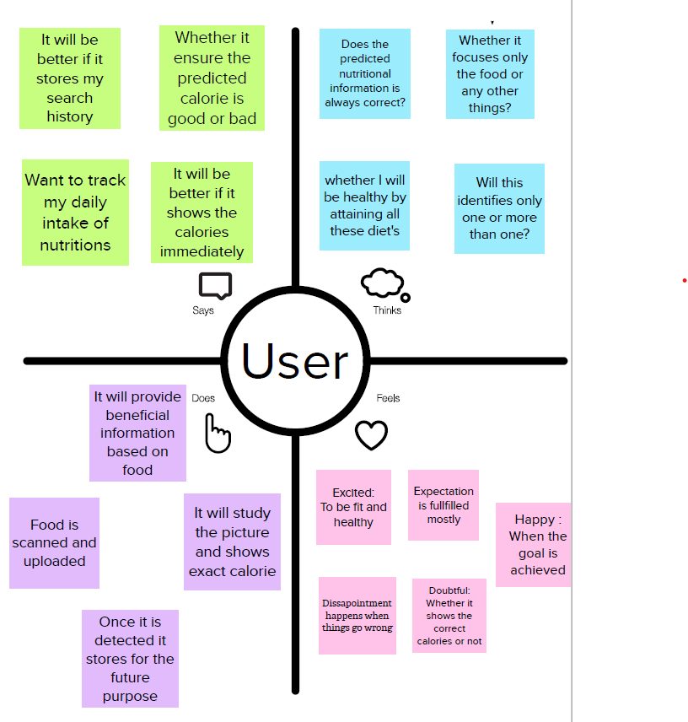

**3.2 Ideation & Brainstorming**

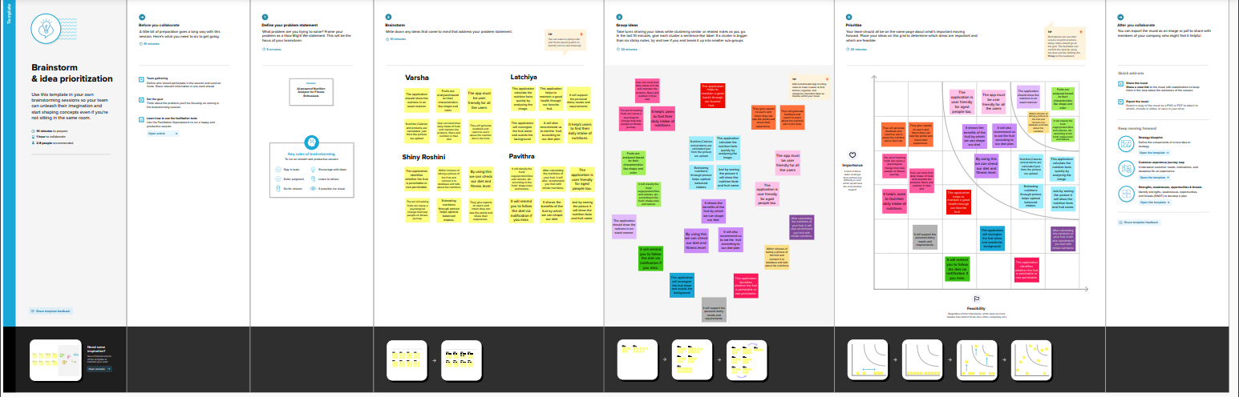

**3.3 Proposed Solution**

|  |  |  |
| --- | --- | --- |
| **S.No.** | **Parameter** | **Description** |
| **1.** | Problem Statement (Problem to be solved) | User needs to analyze the fruits by their characteristics for the various nutritions present in it. |
| **2.** | Idea / Solution description | Food pattern is an important factor. So it is highly recommended in order to prevent all health issues based on AI on nutrition |
| **3.** | Novelty / Uniqueness | Accurate nutritions can be analyzed based on the characteristics of the fruit. |
| **4.** | Social Impact / Customer Satisfaction | Helps people to know about the essential nutritional elements present in the fruits and so they can maintain their health by eating nutrition rich fruits. |
| **5.** | Business Model (Revenue Model) | • AI in nutrition plays a significant role in offering the extraordinary potential for preventing diseases and better treatment methods.  • We take picture of the fruits and do image processing using user interface and analyze the nutrients |
| **6.** | Scalability of the Solution | The software will predict accurate solution based on the trained data. |

**3.4 Problem Solution fit**

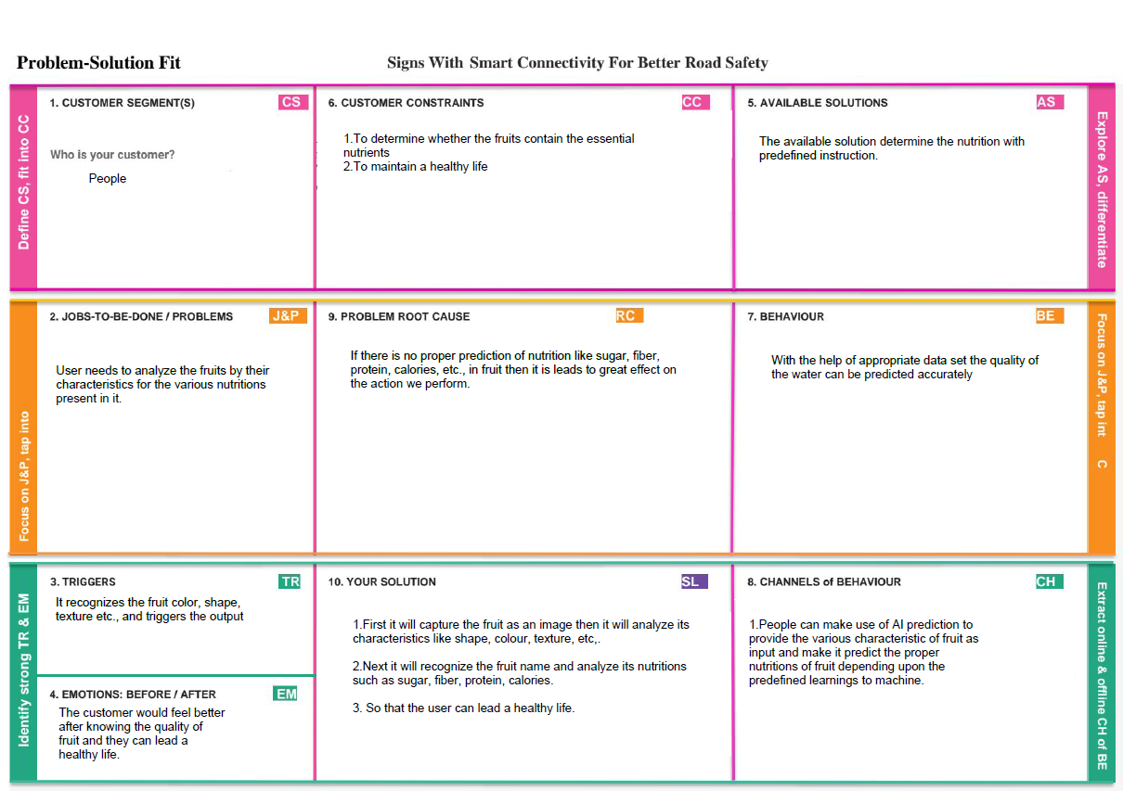

**4. REQUIREMENT ANALYSIS**

**4.1 Functional requirement**

|  |  |  |
| --- | --- | --- |
| **FR No.** | **Functional Requirement (Epic)** | **Sub Requirement (Story / Sub-Task)** |
| FR-1 | User Registration | Registration through Gmail  Registration through Phone Number |
| FR-2 | User Confirmation | Confirmation via Email  Confirmation via OTP |
| FR-3 | User details storage | Storing user details via database |
| FR-4 | User Scanning fruits image | Uploading images of fruits via camera |
| FR-5 | Recognize the fruits | Based on the shapes, colours and textures the fruits are classified |
| FR-6 | Predicting the nutrition in fruits | Using the datasets the nutritions are analyzed |

**4.2 Non-Functional requirements**

|  |  |  |
| --- | --- | --- |
| **FR No.** | **Non-Functional Requirement** | **Description** |
| NFR-1 | **Usability** | User can analyse the amount of nutrition like sugar, fibre, calories and protein in fruits. |
| NFR-2 | **Security** | It provides a secured way for predicting the fruits and maintains the data. |
| NFR-3 | **Reliability** | Almost the nutrition of fruits are reliable. |
| NFR-4 | **Performance** | Checking whether the fruits and their nutritions are predicted correctly or not. |
| NFR-5 | **Availability** | It will be available for any time. |
| NFR-6 | **Scalability** | The software will predict the accurate solution based on the trained data. |

**5. PROJECT DESIGN**

**5.1 Data Flow Diagrams**

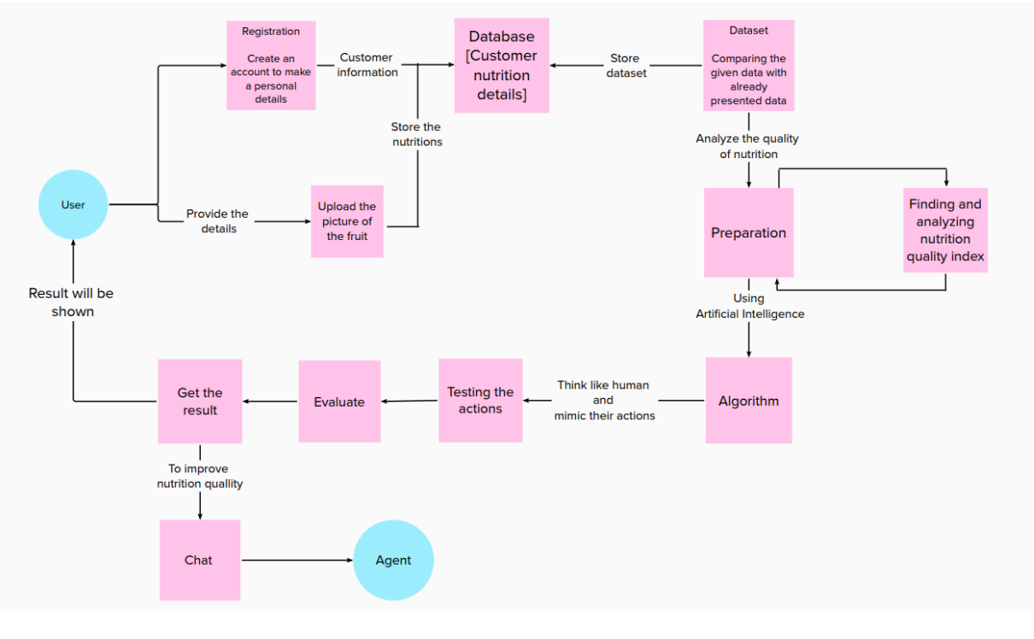

**5.2 Solution & Technical Architecture**

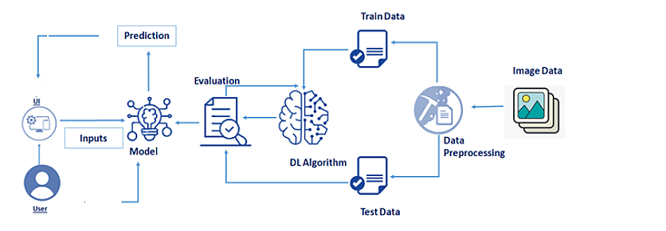

**5.3 User Stories**

|  |  |  |  |  |  |  |
| --- | --- | --- | --- | --- | --- | --- |
| **User Type** | **Functional Requirement (Epic)** | **User Story Number** | **User Story / Task** | **Acceptance criteria** | **Priority** | **Release** |
| Customer (Mobile user) | Registration | USN-1 | As a user, I can register for the application by entering my email, password, and confirming my password. | I can access my account / dashboard |  |  |
|  |  | USN-2 | As a user, I will receive confirmation email once I have registered for the application | I can receive confirmation email & click confirm |  |  |
|  |  | USN-3 | As a user, I can register for the application through Facebook | I can register & access the dashboard with Facebook Login |  |  |
|  |  | USN-4 | As a user, I can register for the application through Gmail | I can register & access the dashboard with Gmail Login |  |  |
|  | Login | USN-5 | As a user, I can log into the application by entering email & password | I can raise the issue in a ticket form |  |  |
|  | Dashboard | USN-5 | As a user, I will follow up with the application | I can see the agent progress on the issue being solved through mail |  |  |
| Customer (Web user) | Registration | USN-1 | As a user, I can register for the application by entering my email, password, and confirming my password. | I can access my account / dashboard |  |  |

**6. PROJECT PLANNING & SCHEDULING**

**6.1 Sprint Planning & Estimation**

|  |  |  |  |  |  |  |
| --- | --- | --- | --- | --- | --- | --- |
| **Sprint** | **Functional Requirement (Epic)** | **User Story Number** | **User Story / Task** | **Story Points** | **Priority** | **Team Members** |
| Sprint-1 | Data collection | USN-1 | We need to collect the data with different fruit images to train the model. | 6 | High | Varsha P  Shiny Roshini J |
| Sprint-1 | Importing the libraries | USN-2 | We have to implement necessary libraries in python package. | 4 | Low | Pavithra A  Latchiya K S |
| Sprint-1 | Image pre-processing | USN-3 | We will upload the image,and then configure ImageDataGenerator class and appy it to trainset and testset. | 10 | Medium | Varsha P  Pavithra A |
| Sprint-2 | Model building | USN-4 | We will get an application with ML model which checks the quality of the image uploaded and initialize the model. | 5 | High | Shiny Roshini J  Latchiya K S |
| Sprint-2 | Adding CNN and Dense layers | USN-5 | We add input convolutional layer,dense layer,max pooling layer,flatten,hidden and output layer to the model | 5 | High | Pavithra A |
| Sprint-2 | Compile the model | USN-6 | We compile the model for trained dataset and configure the learning proces | 2 | Medium | Varsha P |
| Sprint-2 | Train and save the model | USN-7 | We train and save the model for the dataset collected and the data are validated. | 4 | High | Shiny Roshini J |
| Sprint-2 | Save the model | USN-8 | The compiled data are saved and integrated with an android application or web application. | 2 | Low | Latchiya K S |
| Sprint-3 | HTML-Home page | USN-9 | We upload the input as fruit images. | 10 | Medium | Pavithra P  Latchiya K S |
| Sprint-3 | Building flask application | USN-10 | We provide the fundamental details about the usage of application to customer. | 5 | Low | Varsha P |
| Sprint-3 | Run the application | USN-11 | We can see the predicted or recognized nutrition of the images in the application. | 5 | Medium | Shiny Roshini J |
| Sprint - 4 | Train the model on IBM | USN-12 | We train the model in IBM cloud and integrate the results. | 10 | High | Pavithra A  Shint Roshini J |
| Sprint - 4 | Cloud Deployment | USN-13 | We can access the web application | 10 | High | Varsha P  Latchiya K S |

**6.2 Sprint Delivery Schedule**

|  |  |  |
| --- | --- | --- |
| **TITLE** | **DESCRIPTION** | **DATE** |
| **Literature Survey&** | Literature surveywas done by collecting information from various research and technical papers. | 03/09/ 2022 |
| **Information Gathering** |  |
| **Prepare Empathy Map** | Users pros and cons was captured to prepare empathy map and list of problem statements were prepared. | 10/09/ 2022 |
| **Ideation** | Various brainstorming ideas are organized and based on the feasibility and importance top threeideas were prioritized. | 16/09/2022 |
| **Proposed Solution** | Prepare the proposed solution | 25/09/2022 |
| document, which includes the |
| novelty, feasibility of idea, |
| business model, socialimpact, |
| scalability of solution, etc. |

|  |  |  |
| --- | --- | --- |
|  |  |  |
| **Problem Solution Fit** | Prepare problem - solution fit | 05/10/2022 |
| document. |
| **Solution Architecture** | Prepare solution architecture | 05/10/ 2022 |
| document. |

**6.3 Reports from JIRA**

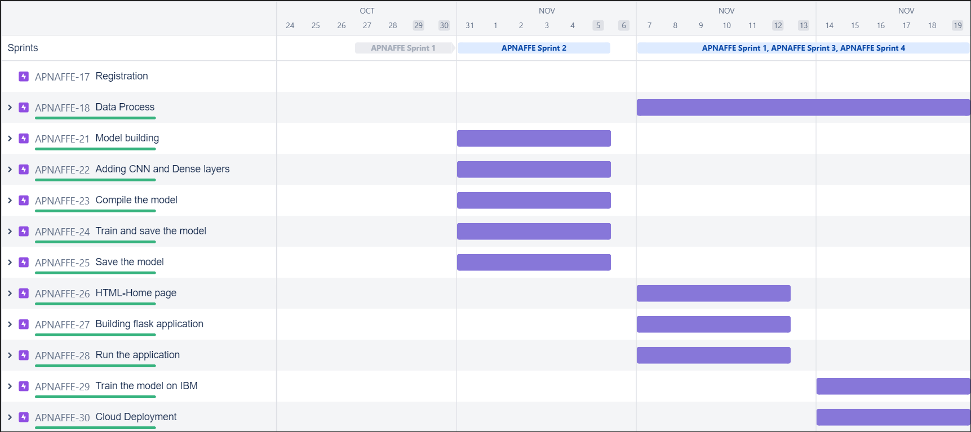

**7. CODING & SOLUTIONING (Explain the features added in the project along with code)**

**7.1 Feature 1**

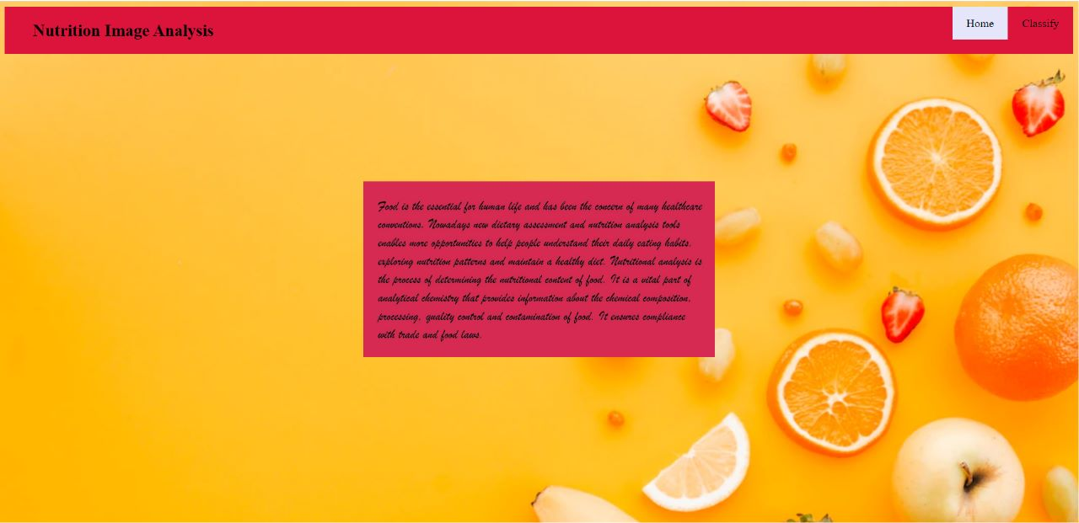

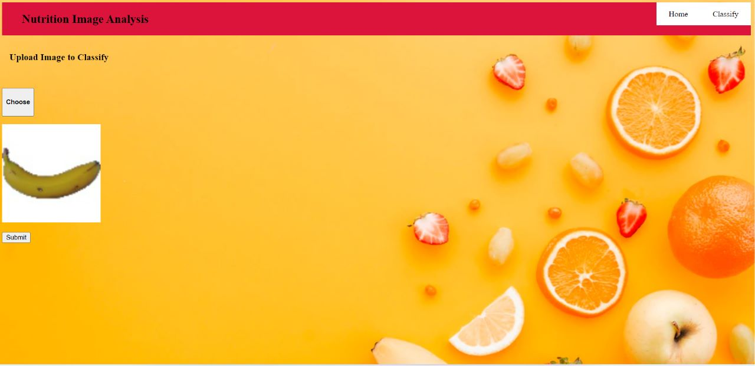

**7.2 Feature 2**

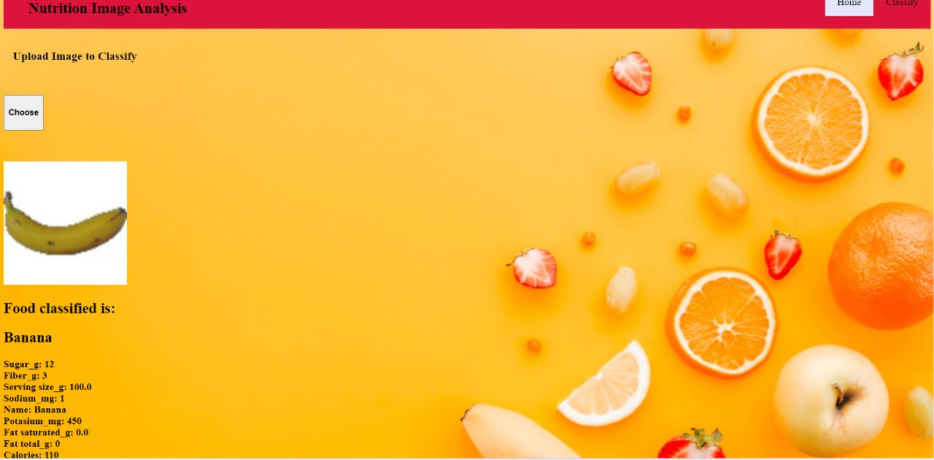

**8. TESTING**

**8.1 Test Cases**

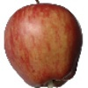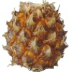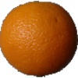

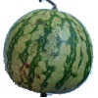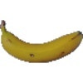

**8.2 User Acceptance Testing**

# Defect Analysis

|  |  |  |  |  |
| --- | --- | --- | --- | --- |
| **Section** | **Total Cases** | **Not Tested** | **Fail** | **Pass** |
| Print Engine | 10 | 0 | 0 | 7 |
| Client Application | 9 | 0 | 0 | 9 |
| Security | 10 | 0 | 0 | 8 |

|  |  |
| --- | --- |
|  |  |
|  |  |

This report shows the number of resolved or closed bugs at each severity level, and how they were resolved

|  |  |  |  |  |  |
| --- | --- | --- | --- | --- | --- |
| **Resolution** | **Severity 1** | **Severity 2** | **Severity 3** | **Severity 4** | **Subtotal** |
| By Design | 7 | 8 | 8 | 7 | 30 |
| Duplicate | 1 | 0 | 1 | 0 | 2 |
| External | 0 | 1 | 0 | 1 | 2 |
| Fixed | 9 | 7 | 8 | 6 | 30 |
| Not Reproduced | 0 | 0 | 1 | 0 | 1 |
| Skipped | 0 | 2 | 1 | 1 | 4 |
| Won't Fix | 0 | 0 | 0 | 1 | 1 |
| Totals | 17 | 18 | 19 | 15 | 69 |

# Test Case Analysis

This report shows the number of test cases that have passed, failed, and untested

|  |  |  |  |  |
| --- | --- | --- | --- | --- |
| Outsource Shipping | 2 | 0 | 0 | 1 |
| Exception Reporting | 6 | 0 | 0 | 5 |
| Final Report Output | 9 | 0 | 0 | 8 |
| Version Control | 3 | 0 | 0 | 2 |

|  |  |
| --- | --- |
|  |  |
|  |  |

**9. RESULTS**

**9.1 Performance Metrics**

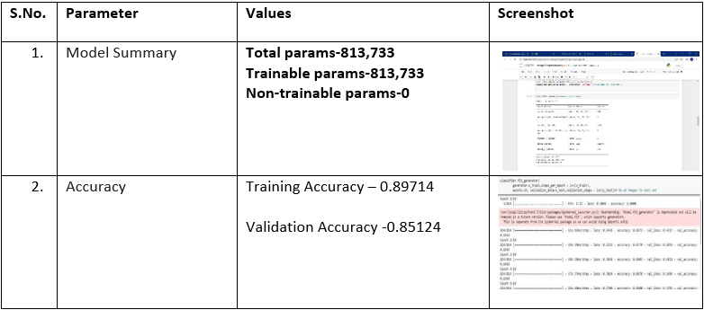

**10. ADVANTAGES & DISADVANTAGES**

**ADVANTAGES:**

Food patterns and diet are important factors to improve the lifestyle by preventing diseases. The food industry comprises complexities, and the journey for innovation in the food industry is long, from idea generation to commercialization. It is reported that diet significantly influences the evolution of CNCD (chronic non-communicable diseases), including, cardiovascular diseases, depression, and obesity. Further, product ideas and advanced packaging demand thorough data collection, testing, and certification before approaching consumers. If this work is performed manually, it brings high possibilities of errors that ultimately lead to time and money wastage with no beneficial outcomes. Here AI in nutrition plays a significant role in offering the extraordinary potential for preventing diseases and better treatment methods.

Traditional data recording and calculation methods were tedious and not free from human errors; luckily, disruptive digital technologies stepped in to record data and calculated mission-based statistics effectively. Transformation offers a strong basis to use previous data to better the next generation. Artificial intelligence and machine learning in nutrition use raw data and extract competitive features that are advantageous for predicting better dietary plans.

Food patterns and diet are important factors to improve the lifestyle by preventing diseases. The food industry comprises complexities, and the journey for innovation in the food industry is long, from idea generation to commercialization. It is reported that diet significantly influences the evolution of CNCD (chronic non-communicable diseases), including, cardiovascular diseases, depression, and obesity. Further, product ideas and advanced packaging demand thorough data collection, testing, and certification before approaching consumers. If this work is performed manually, it brings high possibilities of errors that ultimately lead to time and money wastage with no beneficial outcomes. Here AI in nutrition plays a significant role in offering the extraordinary potential for preventing diseases and better treatment methods.

**DISADVANTAGES:**

As the world grows more fitness-conscious with passing time, the demand for technological solutions to cater to this burgeoning demand is diversifying. Lately, a number of startups in India and worldwide are using predictive analytics artificial intelligence and natural language processing to help scores of fitness enthusiasts to track and monitor their nutrition and calorie intake.

In India, this global trend has had a positive impact on scores of startups and websites catering to this segment. AI and its various subsets have been leveraged by these platforms to identify the calorie intake and also to make food recommendations for a healthy diet. In most cases, what we see is that these platforms act as a data repository where while providing real-time information to its users.

**11. CONCLUSION**

One should develop good nutritional habits with a balanced diet right from early age. Since such habits cannot be changed overnight, children should be taught the value of eating nutritional food and ill effects of junk food in life. A balance diet and appropriate meal timings are important for a healthy body and mind. Eating nutritious food not only helps in weight management and disease prevention in adults but also contributes proper growth of children and their better performance in studies and sports. Nutrition is the broader term which is not limited to developing only healthy dietary habits but also a healthy lifestyle patterns from an early age. A healthy lifestyle excludes smoking, alcohol consumption etc and includes regular exercise, regular meals as well as appropriate sleeping hours. Learning such things from early age helps one to lead a healthy life as an adult and even in old age. Thus a proper nutrition for everyone can enhance the productivity of individuals and contribute to development of a nation as a whole. Nutrition education is an important factor in overall improvement for society health and prevention of all forms of malnutrition. For spreading such education schools are ideal platforms, for promoting lifelong healthy eating habits and lifestyles in community. Most countries nowadays implement health education programme in schools which include feeding to students, deworming, vitamin and mineral supplementation, etc. Children must understand the importance of minerals, vitamins proteins, fluid balance etc as well as limiting calorific value of food that one should consume at different ages. All of us must realize the value and significance of good nutritional habits for a longer and healthier lifeOne should develop good nutritional habits with a balanced diet right from early age. Since such habits cannot be changed overnight, children should be taught the value of eating nutritional food and ill effects of junk food in life. A balance diet and appropriate meal timings are important for a healthy body and mind. Eating nutritious food not only helps in weight management and disease prevention in adults but also contributes proper growth of children and their better performance in studies and sports. Nutrition is the broader term which is not limited to developing only healthy dietary habits but also a healthy lifestyle patterns from an early age. A healthy lifestyle excludes smoking, alcohol consumption etc and includes regular exercise, regular meals as well as appropriate sleeping hours. Learning such things from early age helps one to lead a healthy life as an adult and even in old age. Thus a proper nutrition for everyone can enhance the productivity of individuals and contribute to development of a nation as a whole. Nutrition education is an important factor in overall improvement for society health and prevention of all forms of malnutrition. For spreading such education schools are ideal platforms, for promoting lifelong healthy eating habits and lifestyles in community. Most countries nowadays implement health education programme in schools which include feeding to students, deworming, vitamin and mineral supplementation, etc. Children must understand the importance of minerals, vitamins proteins, fluid balance etc as well as limiting calorific value of food that one should consume at different ages. All of us must realize the value and significance of good nutritional habits for a longer and healthier life

**12. FUTURE SCOPE**

Holistic Nutritionist: Primary works of a nutritionist includes providing proper guidance related to food and the nutritional value associated with it. A holistic nutritionist is generally someone who takes care of a person’s eating habits so as to improve his/her health. Clinical Dietetics/Nutrition: A clinical dietitian/nutritionist takes care of a particular sect of people. As the name suggests, clinical dietitian works in either inpatient settings or outpatient settings. He/she is a medical specialist and under this head, the candidate has to take care of a particular area of the health. These medical specialties include pediatrics, renal, diabetes, nutrition support, etc. Sports Nutritionist: In order to participate in sports, one has to be quite healthy. As different foods have different impacts on the body, it becomes really important to monitor what one eats. A Sports nutritionist is a person who prepares a proper diet for the sportspersons so that they become able to give optimum output in the field. Health Coach: It might sound like something associated with sports but actually, it is not. Health coaching is one type of constructive and strategically executed program where the nutritionists put evidence-based skillful conversation and clinical interventions to use so as to safely engage the patients into a health behavior change. Public Health Nutrition: As of now, the need to reform the health standards and food consumption is alarmingly high. Numbers and numbers of health issues are encircling humankind. The Governments of various countries have constituted the specific government, non-government, and government-aided bodies to meet the provided standards of health. The UNO has brought about 10 major health issues which have plagued human health across the globe. With a thought of combating those issues, there have been numerous bodies incepted and so one can become a part of those teams. Nutrition Education and Research: For some, it might look like a way simple job but it is important. Even in complex lives we live, the simpler things have proved to be of great importance. The candidates always have an option to start teaching in any of the schools or colleges. If not so, the students can conduct researches in specific areas of nutrition and dietetics. The students have a leeway to join research settings, overseeing clinical trials and interventions. Business and Industry: there are innumerable industries and organizations which have food as their primary product/service. Due to a lot of health concerns, these companies need to employ a nutritionist or a specialist in order to monitor their productions. In Pharmaceutical companies, food manufacturing companies, eating franchises, etc there is a need for nutritionists who can work in marketing, quality control, and development. Private Practice/Consulting: You always have an option to be your own boss, thanks to privatization! You certainly are at liberty to work on your own conditions. After this program, you can easily and very effectively practice this by commencing your own business. In this consulting job sphere, the students have to guide the clients on areas such as Diabetes management, weight management, eating disorder and many more. Nutritionist in school/clubs/restaurants/hotels: All the sectors such as schools, clubs, hotels, restaurants, etc need to have someone who overviews and examines the food being served. Nobody wants to become notorious by serving bad quality food or food which proves to be fatal. So, the graduates have one more career option for them. Moreover, there are numerous options to becoming a nutritionist. Medical Nutrition Therapy: Quite often it happens that you think you have a disease and when you reach the doctor's cabin he tells you that actually, it is your diet that is interrupting your health. Then what to do? Turn to a medical nutrition therapist.

**13. APPENDIX**

**GITHUB LINK**

https://github.com/IBM-EPBL/IBM-Project-9209-1658987101

**WORKDEMO LINK:**

**SOURCE CODE:**

import pandas as pd

import cv2

import os

import numpy as np

import random

import pickle

import h5py as h5

train_data='/content/contentdriveMyDriveTRAIN_SET/MyDrive/TRAIN_SET'

test_data='/content/drive/MyDrive/TEST_SET-20221117T140252Z-001'

from keras.preprocessing.image import ImageDataGenerator

x_train = train_datagen.flow_from_directory('/content/drive/MyDrive/TRAIN_SET',target_size=(64,64),batch_size=5,color_mode='rgb',class_mode='sparse')

x_test = test_datagen.flow_from_directory('/content/drive/MyDrive/TEST_SET-20221117T140252Z-001',target_size=(64,64),batch_size=5,color_mode='rgb',class_mode='sparse')

print(x_train.class_indices)

print(x_test.class_indices)

from collections import Counter as c

c(x_train .labels)

import numpy as np

import tensorflow

from tensorflow.keras.models import Sequential

from tensorflow.keras import layers

from tensorflow.keras.layers import Dense,Flatten

from tensorflow.keras.layers import Conv2D,MaxPooling2D,Dropout

from keras.preprocessing.image import ImageDataGenerator

model=Sequential()

classifier = Sequential()

classifier.add(Conv2D(32,(3,3), input_shape=(64,64,3), activation='relu'))

classifier.add(MaxPooling2D(pool_size=(2,2)))

classifier.add(Conv2D(32,(3,3),activation='relu'))

classifier.add(MaxPooling2D(pool_size=(2,2)))

classifier.add(Flatten())

classifier.summary()

classifier.compile(optimizer='adam', loss='sparse_categorical_crossentropy', metrics=['accuracy'])

classifier.fit_generator(generator=x_train,steps_per_epoch = len(x_train), epochs=20, validation_data=x_test, validation_steps=len(x_test))

classifier.save('nutrition.h5')

from tensorflow.keras.models import load_model

from keras.preprocessing import image

model = load_model("nutrition.h5")

from tensorflow.keras.preprocessing import imagea

img = image.load_img('/content/drive/MyDrive/TEST_SET-20221117T140252Z-001/TEST_SET/APPLES/152_100.jpg',grayscale=False,target_size= (64,64))

x = image.img_to_array(img)

x = np.expand_dims(x,axis = 0)

pred = np.argmax(model.predict(x),axis=1)

pred

index=['APPLES', 'BANANA', 'ORANGE', 'PINEAPPLE', 'WATERMELON']

result=str(index[pred[0]])

result